COMMUNICATE No. 10
Arrival to „Lithuanian HF CUP 2024“ registration place schematic and coordinates
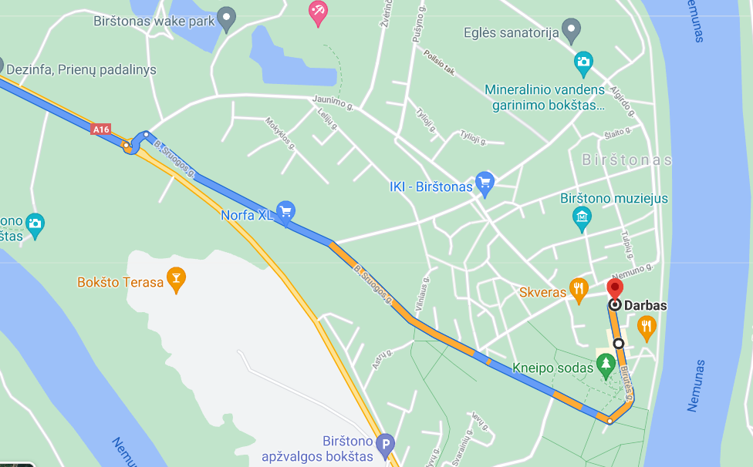
Birutės 19, Birštonas 59217 GPS: 54.602626, 24.035519

Arrival to „Lithuanian HF CUP 2021“ registration place building is in photo below:
