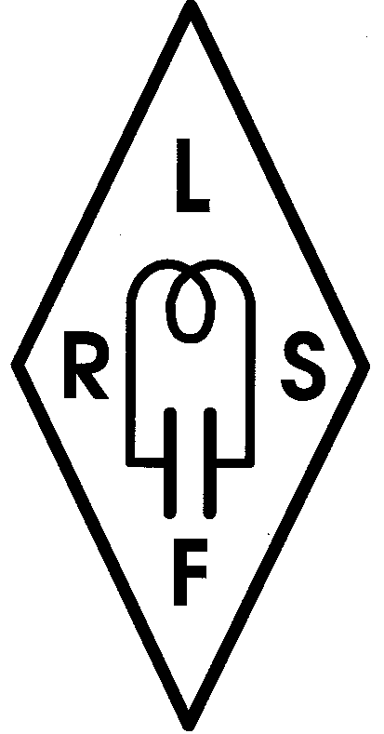
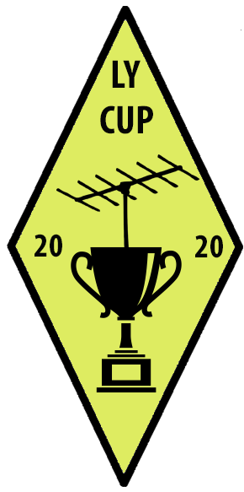
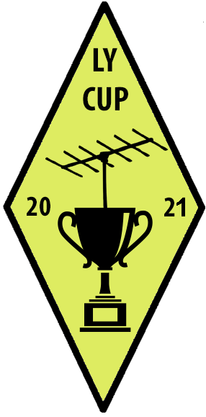
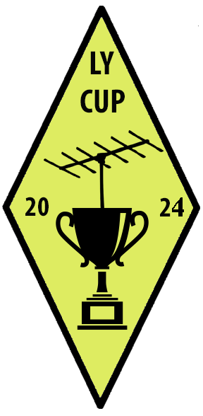
Lithuanian HF CUP – 2024

Agenda

11⁰⁰ -Registration
11⁰⁰ – 15⁰⁰ -Participant place preparation
15⁰⁰ -Opening ceremony
15⁰⁰ – 17⁰⁰ -Briefing, tech-control, referees appointment
17⁰⁰ – 17⁵⁵ -Final place preparation
17⁵⁵ -Callsign delivery to the participants
18⁰⁰ – 19³⁰ -Contest
19³⁰ – 20⁰⁰ -Log submission to Headquarter
20⁰⁰ – 20³⁰ -Judging
21⁰⁰ -Awards, closing ceremony

Lithuanian HF CUP – 2024 org. committee

